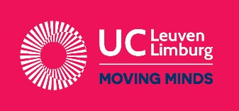

University College Leuven-Limburg
Faculty of Health and Social Work
HEALTH-campus Gasthuisberg
invites you to its 10th INTERNATIONAL WEEK

Date: 05–09 March 2018 Languages : English, French, Dutch
Place: Herestraat 49, 3000 LEUVEN - BELGIUM

Dear colleague

We warmly invite you to join us during our 10th (!) INTERNATIONAL WEEK.
This is an excellent opportunity to:
- promote your institutions exchange programmes among:
  - students;
  - faculty;
- find out the latest news about our university college,
- write or explore project proposals with us or other visiting faculty;
- network;
- experience Belgium from a socio-cultural point of view;
- bring your students and engage them in the international experience;
- have fun.

Incoming students are welcome too. Most programmes offer the opportunity to join one of the international student projects.

More information
Please find more information about programme, accommodation, costs, cultural programme, travel to Leuven, etc. on our updated international wiki: https://international.ucll.be/?q=content/2018-international-week

Subscription
Please subscribe before January 27th by completing the online application form on the wiki.

We are looking forward to meeting you in Leuven!

Yours internationally,
Heidi Cosyns - Vicky De Preter - Frank Delaere - Laurent Jacoby - Sylvie Dewaele – Ann Deschamps – Carine Debaere - Mieke Clement - Goedele Buyse – Karen Lauwerier

 | Please feel free to share this invitation to other colleagues who might be interested.
InternationalHealth@UCLL.be
Campus Gasthuisberg
Herestraat 49 • B-3000 Leuven
+32 16 375 245 • +32 16 375 200

