Virtual Reality Summer School
“Immersive Presence, Augmented Visualization and Advanced Interaction”

June 18-23, 2017 Torre dell’Orso (Lecce), Italy

http://www.salentoavr.it/vr_summer_school/
The Virtual Reality Summer School 2017 will take place in Torre dell’Orso (Lecce), Italy from 18th to 23th June 2017 with the aim to propose a privileged moment for stimulating discussions and exchanging scientific experiences and technical results related to the Virtual Reality and Augmented Reality technologies.
Lectures will span topics from virtual environments and augmented reality applications to 3D user interfaces and required technology to enable these environments to a wide range of applications.
Master students are strongly encouraged to participate at the school. Academic and industrial researchers as well as Ph.D. students are invited to present the progresses of their research works, challenges and corresponding solutions they are putting forward.
Another aim of Virtual Reality Summer School is to stimulate the start up of new European collaborations among researchers concerning the Virtual and Augmented Reality techologies in order to find opportunities to submit new European projects proposals (Horizon 2020).
In the summer school has been planned invited speaker lectures, practical lectures, young researcher presentations and social events.
The main thematic areas of the Virtual Reality Summer School are:
- medicine
- cultural heritage and arts
- education
- industry and military
- games and serious games
- interaction and presence in VE
Important dates
- proposal to presentation on behalf of Ph.D. students and researchers: April 30, 2017
- registration deadline and fee payment: May 15, 2017
- VR Summer School: June 18-23, 2017
Virtual Reality Summer School 2017 will take place at the Hotel Belvedere in Torre dell’Orso (Lecce).
Special accommodation fee will be reserved only to VR Summer School participants, teachers of the school and their accompanying persons. Camsites nearby provide bungalows and mobile homes that could be an alternative accommodation option.
Hotel Belvedere
Via Alessandro Volta, 37
73026 Torre dell’Orso (Lecce), Italy
www.hotelbelvederesalento.com

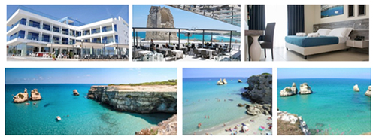

Copyright © 2017 University of Salento, All rights reserved.
. Our mailing address is:
University of Salento
Via per Monteroni, Ecotekne
Lecce, Le 73100
Italy
Add us to your address book
Want to change how you receive these emails?
You can update your preferences or unsubscribe from this list


